**Population demographics and dynamics of coconut crabs (*Birgus latro*) on Aldabra Atoll, Seychelles**

Jennifer Appoo, Fernando Cagua, Janske van de Crommenacker *et al.*

Seychelles Islands Foundation, P.O. Box 853, Victoria, Mahé, Seychelles

aldabrascience@sif.sc

**Abstract**

A nine year study on *Birgus latro* was conducted on Aldabra Atoll to investigate the structure and the spatial and temporal dynamics of the population. *B.latro* individuals were assessed along two parallel transects located at different distances from the shore. The mean density was 35.4 ± 1.69 ind./ha and has remained stable over the study period, with a higher abundance occurring between February to June. The *B.latro* population on Aldabra is heavily skewed towards males (sex ratio 1:0.32 male to female) and size sexually dimorphic with males being larger (mean thoracic length 40.9mm) than females (mean thoracic length 30.6mm). Larger male *B.latro* were more abundant between during the first half of the year far from shore while female *B.latro* were more abundant during the second half in both inland and shore areas, with larger females encountered closer to shore. Large male densities peaked around the new moon whereas female densities were higher close to the full moon. Aldabra Atoll hosts a significant, stable and unexploited *B.latro* population, representing a refuge for this species, which is recorded to be on decline elsewhere throughout their range. The Aldabra population therefore holds the potential to repopulate other protected areas in the Western Indian Ocean.

**Key words**: *Birgus latro*, coconut crabs, density, sex ratio, population dynamics, moulting, reproductive season, Aldabra Atoll.

**Introduction**

Present extinction rates are exceptionally high, estimated to be around 100 extinctions per million species per year (Pimm et al. 2014) with future rates of extinction likely to be 10,000 times higher (de Vos et al. 2014). More than 10,600 species are classified as data deficient on the IUCN Red list (Veron et al. 2016) impacting their likelihood of active conservation measures being adopted. The largest land arthropod, the coconut crab (*Birgus latro),* falls into this category (Eldredge 1996) due to limited information on the status of the different populations (Drew et al. 2010). Although *B.latro* has a broad geographical range in the tropical Indo-Pacific region, the size and distribution of the populations have been significantly reduced in areas where the species were sympatric with humans (Schiller 1992). This decline is mostly attributed to loss of habitat and unmanaged harvesting for human consumption. In the Indian Ocean, the distribution is now largely confined to three populations centred on Aldabra Atoll (Seychelles), Chagos Archipelago and Christmas Island (Lavery et al. 1996). *B.latro* is locally extinct in Mauritius (Eldredge 1996) and is believed to be no longer present on Mayotte and the Comoros Islands (Poupin et al. 2013). In the Seychelles, *B.latro* has been historically overexploited for food on the granitic inner islands and inhabited outer islands. With the exception of Aldabra Atoll, *B.latro* occurs throughout Seychelles in low incidence with recent opportunistic records on two granitic islands and occasional sightings on the outer islands (Poupin et al. 2013).

On Aldabra *B.latro* has benefited from complete protection since it's designation as a special reserve in 1981 and UNESCO World Heritage Site in 1982. *B.latro* is widely distributed throughout the atoll, inhabiting rock crevices, deep potholes, vegetation and sandy areas (Grubb 1971). In spite of being one of the last remaining viable populations in the Indian Ocean, the status of Aldabra’s *B.latro* population has never been defined. Previous studies have only established the species role on the atoll. Haig (1984) described *B.latro* as a scavenger of major importance on the remains of dead tortoises, tortoise and marine turtle eggs and hatchlings. Alexander (1976) identified several important ecological roles of the *B.latro* on Aldabra: as scavengers they remove rotting material and so reduce the number of carrion breeding flies, they help to decompose leaf litter, they contribute greatly to seed dispersal, particularly figs, providing a food source for birds in the juvenile stage and in turn influence the populations of crab species upon which the birds prey. They also contribute to soil aeration and erosion through their burrowing activity (Alexander 1976).

This paper presents the results of a nine year study on the demographics and dynamics of *B.latro* on Aldabra Atoll. Individual counts and biometrics data were collected on *B.latro* individuals in two different sampling areas at regular intervals over the study period. The aim was to define a baseline of the population structure and its spatial and temporal variability. The overall goal is to provide information on the status of this population, required not only to design future monitoring but which will also contribute to giving *B.latro* the conservation leverage it deserves.

**Materials and methods**

Study site

Aldabra Atoll (9°25′0.05″ S, 46°24′59.94″ E) lies in the Western Indian Ocean and forms part of the Seychelles archipelago. It is located approximately 1100 km south west of Mahé, the principal island of the Seychelles and 420km from Madagascar. Aldabra is the second largest raised coral atoll, ca. 34 km long and 14 km wide. The atoll is comprised of four main islands; Grande Terre, Malabar, Picard and Polymnie (Fig. 1) surrounding a shallow lagoon and separated by tidal channels. Aldabra is composed of a characteristic and irregular coral limestone formation termed as ‘champignon’. The terrestrial environment is dominated by a dense scrub of varying height, either continuous or in a mosaic with open rocky ground (Hnatiuk & Merton 1979). Aldabra’s climate is determined by two distinct seasons: the wet season of the northwest monsoon from November to April (Stoddart and Mole 1977), while between May to October there are lower rainfall resulting from the southeast monsoon winds.

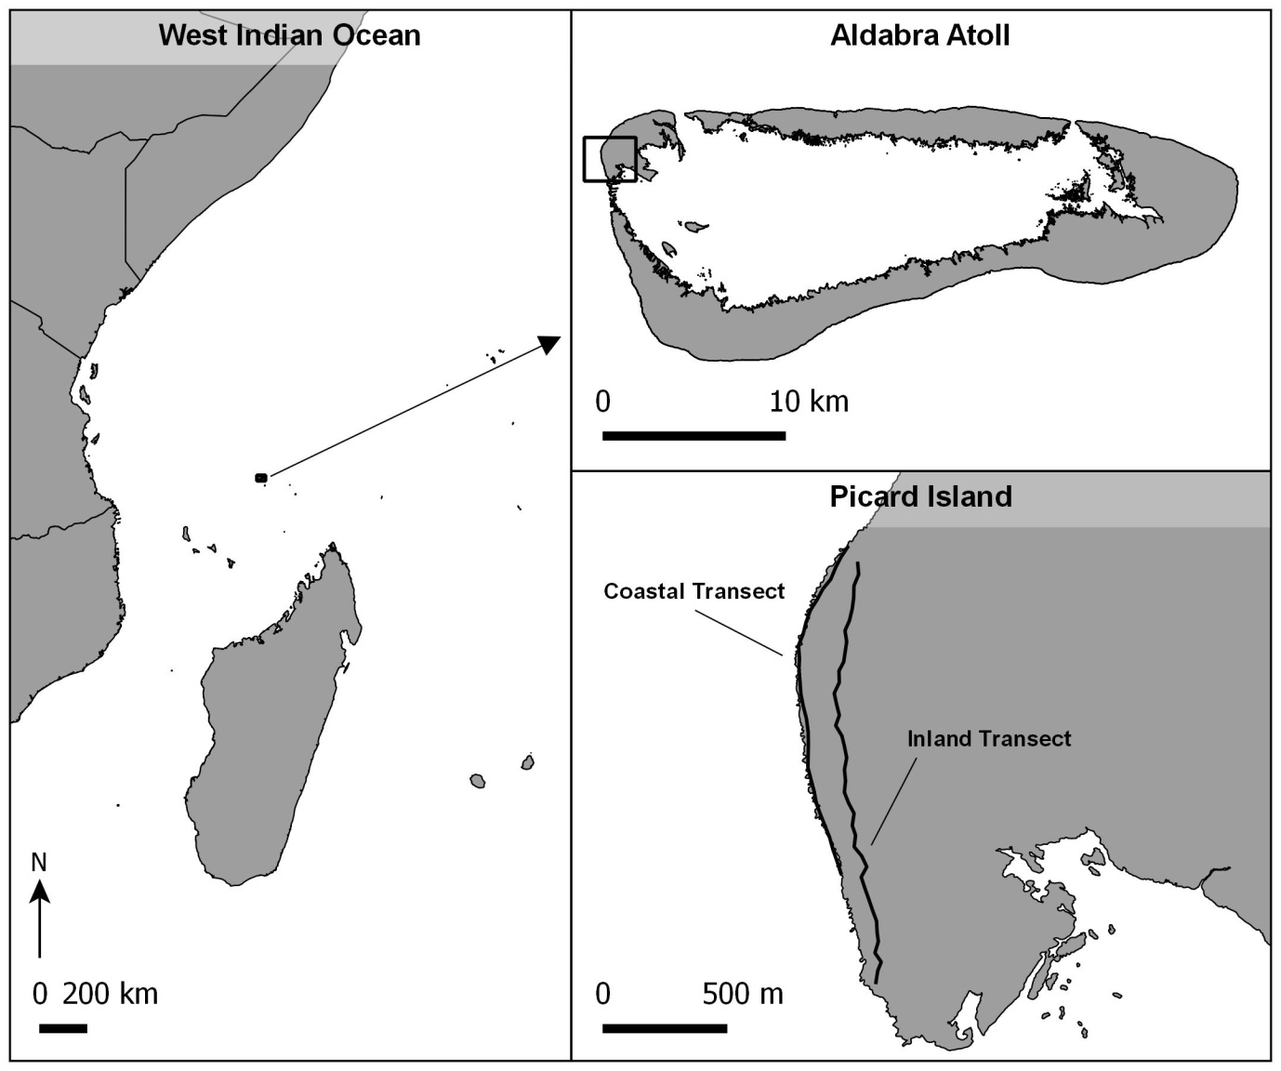

Figure 1: Location of Aldabra Atoll in the Western Indian Ocean and location of the monitoring transects for *B.latro.*

Sampling

The distribution of *B.latro* is said to be structured by the distance from the coastline (Schiller 1992). Therefore *B. latro* population surveys were conducted on two roughly parallel transects established at different distances from the shore (Fig. 1). The coastal transect was 1.4km long, composed of 27 lineal sections of 50m and separated from the shore by distances ranging between 1 and 26m. The inland transect was 1.8km long, composed of 39 lineal sections with distances from the shore ranging between 38 and 177m. The two transects were surveyed simultaneously after sunset, roughly every two weeks from January 2007 to May 2016. All *B.latro* individuals encountered within five meters on either side of the mid transect line were recorded. For each individual encounter, the distance to the mid transect line was estimated to the nearest meter, the sex was identified, the colour of the morph was noted, and in the case of females whether they were carrying eggs or not. Pistorius (2006) established a highly significant relationship between weight and thoracic length for the *B.latro* population on Aldabra, corresponding to findings in other studies (Amesbury 1980; Anagnostou and Shubart 2014; Helagi et al. 2015). Therefore the thoracic length, the linear distance between anterior and posterior borders of the thoracic groove (Helfman 1973), of each individual encounter was measured using vernier callipers.

Several studies (Amesbury 1980; Fletcher et al. 1990 and Held 1963 cited by Drew et al. 2010) noted a distinct expansion of the abdomen on *B.latro* prior to moulting. Pleonal expansion has also been linked to the reproductive condition of females, as it can be indicative of gonad development (Fletcher et al. 1991; Sato and Yoseda 2009). Therefore during each encounter the degree of pleonal expansion using a four-level categorical scale was recorded. In this scale, 1 was assigned to individuals in which all tergal plates are touching each other or there is only a small gap between the most posterior tergal plate (first plate) and the next (second plate). An index of 2 was assigned to those in which the pleon was slightly swollen and the fleshy abdomen is visible between the first and second plates, and somewhat visible between the second and third plate. An index of 3 was assigned if the pleon was swollen and the fleshy abdomen is clearly present between the first, second and third plates, and somewhat visible between the third and the fourth plate. Finally, an index of 4 indicates a strongly swollen pleon and the fleshy abdomen is visible between all tergal plates. In addition, *B. latro* behaviour has been hypothesised to be influenced by humidity (Schiller 1992) and the phase of the moon (Amesbury 1980; Sato and Yoseda 2009; Drew et al. 2010). Therefore in each survey it was noted whether the soil was moist due to ongoing or previous rain as well as the phase of the moon.

**Data analysis**

Density and abundance

The density of *B. latro* during each survey was estimated using the hierarchical distance sampling model of Royle, Dawson, and Bates (2004) implemented in the R package unmarked (Fiske and Chandler 2011). The numbers of individuals within the five distance categories 0−1, 1−2, 2−3, 3−4, 4−5m were used to estimate the overall density and evaluated the impact that habitat composition had in both the detectability and abundance of *B. latro*. Habitat composition was determined using high resolution satellite imagery (reference) and classified into eight different habitat types. In each transect section the percentage of area occupied by the different habitat types that could affect *B.latro* detectability and/or abundance was calculated. In decreasing order of area occupied these habitats were: open mixed scrub, exposed surface, standard mixed scrub, grasses, mangrove, sand, dense *Pemphis acidula* bush, and champignon.

To maximise differentiation between transect sites and reduce the dimensionality of the data, habitat composition percentages were transformed using a principal component analysis. Finally, the two components were included, explaining the largest proportion of the variance as covariates in the distance sampling model. Due to the large number of surveys, a fixed effects meta-analysis approach was used to ascertain the significance of the covariates. A covariate was determined to significantly affect detectability if its effect was consistent over different surveys, and to significantly affect abundance if its effect was either consistent over surveys or variable but according to the seasons. In each survey, the Akaike Information Criterion (AIC) was used to determine whether the detection process was better approximated by a half-normal, a negative exponential, a hazard-rate, or a uniform distribution function.

Next, a generalised additive model (GAM) was used to determine whether *B. latro* densities varied significantly (i) over the years, (ii) over the yearly cycle, and (iii) over the lunar cycle. Models were fitted using the R package mgcv (Wood 2006a), and the model parsimony was assessed by comparing their AIC values. The phase of the moon during the survey was back calculated using the R package oce (Kelley and Richards 2015) and was defined as a continuous variable from zero to one with both extremes corresponding to new moon, 1/4 for first quarter, 1/2 for full moon, and 3/4 for last quarter (Meeus 1982). Similarly for *B. latro* relative abundances, a GAM was used to quantify the relative effect of the aforementioned variables on the counts of both male and female individuals. As it is plausible that environmental factors interact with habitat requirements, the tensor product interaction between day of the year and distance from shore was included in the model (Wood 2006b).

Sex ratio and sizes

Sex ratios were directly calculated from the individual counts. In addition, due to the potential reference for reproduction, the sex ratio that would be observed if only sexually mature individuals were included was calculated. Full sexual maturity was assumed based on individuals with a thoracic length of and longer than 28mm (Fletcher et al. 1990; Sato and Yoseda 2008; Drew et al. 2010). Thoracic length was also used to determine the differences between males and females. The difference was evaluated by visually inspecting the size distribution for both sexes and a t-test on the length measurements. A set of GAMs were used to infer the effects that time of the year, distance from shore, and phase of the moon may have on the sex ratio and sizes of individuals encountered, with competing models compared using their AIC.

Moulting and reproduction

To understand whether there is evidence of synchronous seasonal moulting, and to provide insight into the onset of reproductive season, two GAMs were constructed, one for each sex, in which the response was the index of pleonal expansion (treated as a numeric variable) and the predictor was the time of the year. To determine the reproductive season of *B.latro* on Aldabra a GAM with a binomial error distribution was constructed with the response variable whether a female was seen carrying eggs during a survey transect or not, with time of the year and phase of the moon as response variables.

**Results**

Density and abundance

Overall, 281 surveys were performed over the study period which led to a total of 8145 individual encounters. The two principal components of the habitat composition explained 81% of the variance found among transect sections. The first component was strongly correlated with an increase on the area covered by open mixed scrub, but mainly with a decrease on percentage of exposed surface. The second component was largely correlated with an increase of grass and with a decrease of standard mixed scrub. These habitat differences, however, did not significantly affect the detectability or the abundances of *B. latro* (Supplementary Information). Overall, based on AIC values, the most parsimonious models were those fitting a negative exponential function to the detection process.

*B. latro* density in the study area varied between 3.2 and 189.4 individuals per hectare, with an overall average density of 35.4 ± 1.69 ind./ha. The overall density shows small variations over the years, but no long term trend is observable (Fig. 2A). Similarly, there was no significant variation on density over the moon cycle (Supplementary Information). Contrastingly, there were important seasonal changes on abundance, being above average between February and June—with a clear peak on April, and below average for the rest of the year (Fig. 2B).

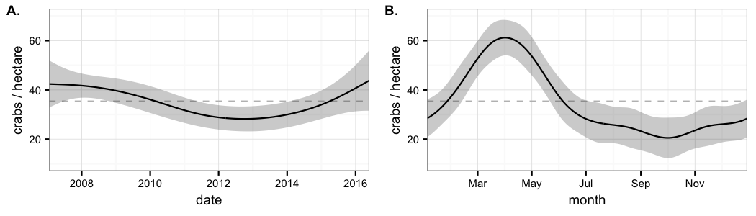

Figure 2: *Birgus latro* density over (A) the years and over (B) the yearly cycle. The solid lines show the values predicted by the GAM, while grey ribbons represent the standard error.

The number of *B.latro* males and females encountered is strongly affected by the time of the year and the distance from shore. In general, male counts in each transect section seem to be the largest during the first half of the year. Within that period, between March−April, males concentrate afar from shore (Fig. 3A). During the same period, when inshore counts are high for males, female counts are higher close to shore. In contrast, during the second half of the year when male counts are the lowest, female counts are at the highest both in coastal and inshore sections, particularly between October and November (Fig. 3A).

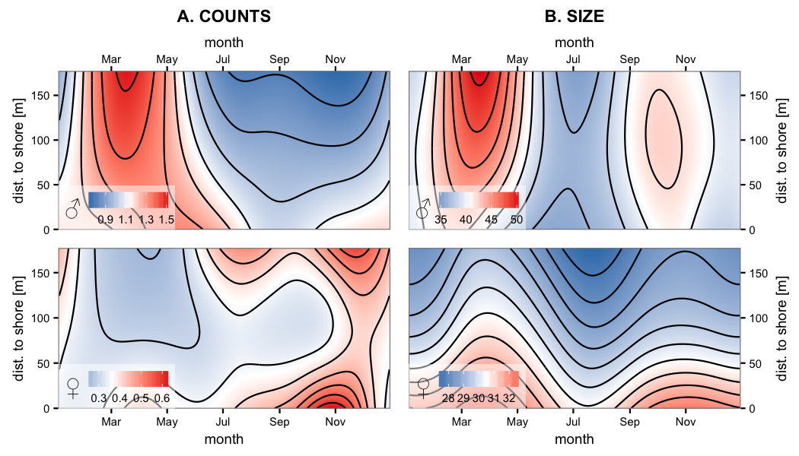

Figure 3: Contour plots of the effect of time of the year and distance from shore on A) the counts and B) the size of both males (top panels) and females (bottom panels). In all panels, shades of red and blue indicate values larger and smaller than the average respectively.

Although moon phase did not affect the overall *B. latro* densities, it had distinct and complementary effects on males and females (Fig. 4A). While female counts are the largest during periods of full moon, males are encountered in higher densities during new moon when the illuminated fraction of the moon is at its minimum.

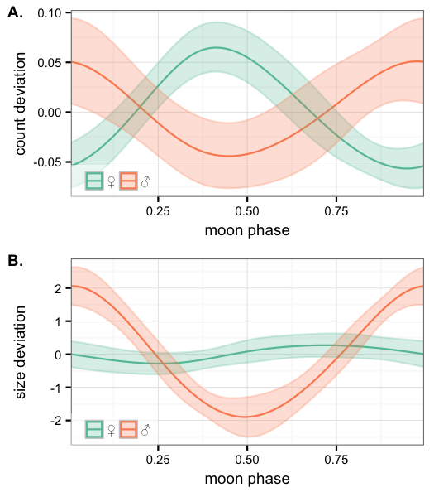

Figure 4: The effect of the phase of the moon on A) the count and B) the size of encountered *B.latro* females (green) and males (orange). The y-axes show the effect on the mean counts (0.36 females and 1.13 males) or the mean sizes (30.5mm thoracic length for fem ales and 40.6mm for males) per transect section. The solid lines show the values predicted by the GAM, while ribbons represents the standard error. The phase of the moon is defined as 0 and 1 for new moon, 0.25 for first quarter, 0.5 for full moon, and 0.75 for last quarter (Meeus 1982).

Sex ratio and sizes

The overall *B.latro* ratio males: females was 1:0.32 (76% male), which increases to 1:0.23 (82% male) if only sexually mature individuals are included. As inferred by the count models, this ratio however, shows significant temporal and spatial variation, ranging between 57% of individuals encountered being male during November in areas close to shore and 86% during March in areas far from shore.

Marked sexual dimorphism was observed (Fig. 5). Overall, males were found to be larger than females: male thoracic length, ranged from 9 to 78mm (mean 40.9mm), while female ranged from 6 to 76mm (mean 30.6mm). The mean size, of both male and female individuals encountered, showed two distinct peaks during the year, one between October and December, and another more pronounced between March and May (Fig. 3B). In addition, the mean sizes were found to be affected by the distance to shore. In general, females encountered close to shore were generally larger than those encountered inland. On the other hand, males found away from the coast were substantially larger than those encountered close to shore. However, this difference on male size between coastal and inshore habitats becomes inconspicuous on December and January and from June to August (Fig. 3B). Furthermore, the size of males encountered close to new moon was significantly larger than that of males encountered close to full moon. In contrast, the size of encountered females showed no variation over the moon cycle (Fig. 4B).

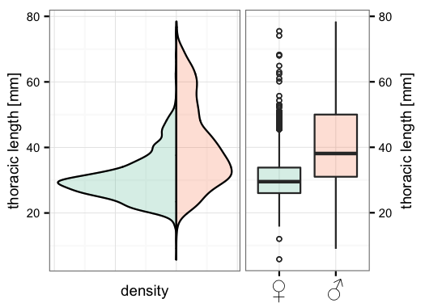

Figure 5: Size distribution of *Birgus latro* on Aldabra for female (green) and male (orange) individuals.

Moulting and reproduction

Males over 30mm were found to exhibit a yearly cycle regarding the size of their pleon, with a clear peak on April-May (Fig.6). In contrast, females encountered in November have the largest pleon. In addition, females show an additional less conspicuous peak of pleon expansion between May and July (Fig. 6).

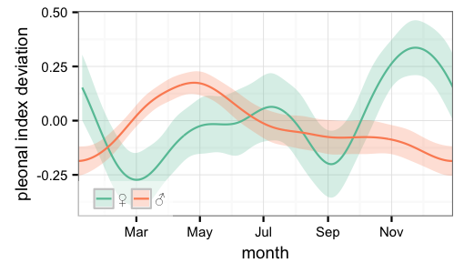

Figure 6: Effect of time of the year on the mean pleon size for *B.latro* females (green) and males (orange). Pleon size was estimated using an index between 1 and 4. An index of 1 indicates that all tergal plates are touching each other of there is only a small gap between the most posterior tergal plate and the next. An index of 4 indicates a strongly swollen abdomen and all tergal plates are divided by thick gaps.

Throughout the monitoring period, few *B.latro* females (14 out of 2071 individuals in 12 out of 438 transect surveys) were ovigerous. Nevertheless, these observations consistently pointed out to a reproductive season between December and March with an increased probability to encounter females carrying eggs just before new moon (Fig. 7).

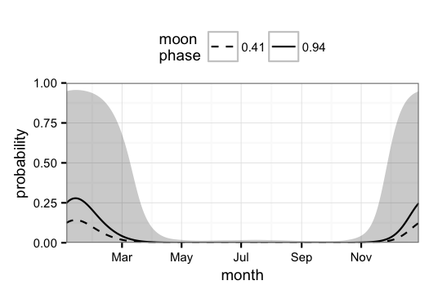

Figure 7: Probability of encountering an ovigerous female during a survey. The solid line and dashed line correspond to the maximum and minimum encounter probability during the moon cycle respectively. A moon phase of 0.41 corresponds to about three days before full moon and 0.94 to around two days before new moon (Meeus 1982). Grey ribbon indicates confidence interval of the mean probability across the year.

**Discussions**

The density of *B.latro* has been stable on Aldabra over the nine years of the study period. The substantial spatial and temporal heterogeneity on observed densities suggests a highly dynamic population, similarly reported on Christmas Island by Drew and Hansson (2014). Aldabra might potentially have one of the most significant *B.latro* populations worldwide likely as a consequence of not being exploited. The other two unexploited populations on Enewetok (5.85 km2) and Taiaro (12 km2) Atolls have high densities, estimated at 147crabs/ha (Helfman 1973) and 190crabs/ha (Chauvet and Kadiri-Jan 1999) respectively, but these islands are relatively small compared to Aldabra Atoll (155km2). Moreover, Drew and Hansson (2014) reported a significant decline in the densities on Christmas Island whose population are partially exploited. Although the survey methodologies used for the above-mentioned assessments are different than the one we used, this study provides a good baseline on the population structure of *B.latro* on Aldabra.

As observed in all studied populations, *B.latro* on Aldabra is size sexually dimorphic, with males being substantially larger than females. Interestingly, the mean thoracic length of *B.latro* recorded on Aldabra is much smaller than all the other studied populations (see Drew et al 2010 for review) for both males and females. One reason for this can be the result of interspecific competition for resources. Hermit crabs of the genus *Coenobita* are abundant on Aldabra (Grubb 1971). As reported by Amesbury (1980) in areas with high abundance of *Coenobita*, the amount of scavengeable material available to *B.latro* may be limited, as well as the availability of gastropod shells for the glaucothoe stage. A second reason may be due to the increased drought frequency on Aldabra reported to have increased from two to six months per year between 1970 and 2013 (Haverkamp et al. 2017). *B.latro* is suggested to exhibit a decrease in the frequency of their foraging activity during the dry season compared to the wet season (Fletcher 1993), thereby resulting in a slower growing population on Aldabra. At the relatively small spatial scale of this study, sex ratio appears to be extremely biased towards males, most likely as a result of the sampling design. Transect studies typically report male bias ratios compared to grid sampling, suggested to be associated to variations in habitat use between sexes (Drew et al. 2012).

The high spatial and temporal variability of *B.latro* density, size and sex is most likely linked with a complex life cycle associated with reproductive migrations, moulting requirements, availability of resources and potentially behavioral variations associated with environmental conditions at a site (Drew and Hansson 2014). From February to May, the overall number of crabs observed is higher than average. This rise is largely due to an increase on the number of males. During this time, large dominant males favour areas further from shore, presumably of higher quality, while females and smaller males are mostly encountered in near-shore habitats. Afterwards, roughly from June to December, the overall number of crabs is lower than average. Again, this is largely due to a decrease on the number of males, particularly of large ones, which are potentially undergoing moulting during the drier months of the year as suggested by Fletcher et al. (1991). During this period, in stark contrast with the lower male density, female counts increase on the second half of the year both in the coastal and inshore areas, likely opportunistically exploiting the available resources left by dominant males (Drew and Hansson 2014). Female densities peak between September to December close to shore which coincides with a period in which males of sexually active sizes are commonly encountered, advocating a breeding migration of female *B.lastro* (Brown and Fielder 1991).

Based on the encounters with ovigerous females the reproductive season on Aldabra occurs with most likelihood between December and March, during the rainy season, though no actual observations of females extruding their eggs have been made. This also corresponds with the period of highest peak of female pleonal expansion in November to December, which is believed to be related to gonad development (Fletcher et al. 1991; Sato and Yoseda 2009). This period coincides with the reproductive seasons observed in other *B.latro* populations in the southern hemisphere (Drew et al 2010). Moreover, signs of synchrony with the moon cycle were found as ovigerous females were mostly encountered during surveys performed close to new moon. This synchrony is likely related to the timing of spawning, nevertheless, it can also be related to timing of egg extrusion (Sato and Yoseda 2009). The timing between mating and egg extrusion is unknown. As female individuals don't possess a seminal receptacle, it is believed that egg extrusion occurs shortly after mating (Sato and Yoseda 2009; Drew et al. 2010).

This study has shown several failings which needs to be addressed for future monitoring. Given the relatively small spatial scale of this monitoring and the large variability in spatial densities, it is advisable that other islands of the atoll are sampled to give better insight on the dynamics of *B.latro*. The subjective assessment categories of abdomen expansion should be replaced with measurement of the ‘index of pleonal expansion’ as described by Sato and Yoseda (2009). Moreover, alternative sampling methods such as grid sampling is recommended which has shown to increase sampling efficiency and reduces bias in sex ratios (Drew et al. 2012). Nevertheless it is advisable that transect methods should be continued, possibly at a reduced frequency, to provide continuity to the long term dataset so as to detect future changes in trends. A mark-recapture study would be useful to estimate the total population size on Aldabra. Drew et al. (2012) found Passive Integrated Transponder (PIT) tags to be a suitable tagging system for use in *B. latro*, providing good apparent retention rates and good return rates relative to other mark-recapture methods. Lastly, a recent black rat (*Rattus rattus*) eradication trial on Aldabra recorded substantial interference by *B.latro* and other hermit crabs to poison bait (Harper et al. 2015). Due to their gregarious behaviour, this poses a potential threat to the species either through direct bait consumption or scavenging on dead animals that have taken baits. Further studies on the factors affecting the gregarious nature of *B.latro* should be investigated as well as other precautionary measures, such as use of crab deterring bait masks. This, together with the information presented here on density and seasonality, will be useful in planning future eradication programs to prevent declines in the population.

**Conclusion**

This study provides one of the longest continuously recorded data set on *B.latro* populations and provides additional insight into the ecology of this species. *B.latro* on Aldabra is highly dynamic due to several factors relating to their life history and availability of resources. With a significant, stable and unexploited *B.latro* population, Aldabra Atoll represents a refuge for this species recorded to be on decline elsewhere throughout their range and a crucial reservoir for repopulating other suitable islands in the Western Indian Ocean (Poupin et al. 2013). Aldabra as a research base is in a privileged position to unravel long held questions on *B.latro*. Its strict protection from human disturbance provides the opportunity to investigate the potential for this species to persist in the face of global climatic changes and provide important lessons for other managed and unmanaged populations elsewhere.

**Acknowledgements**

We would like to thank all the staff of Seychelles Islands Foundation who has contributed to this long term study and support of this manuscript. In particular, thanks to Dr. Pierre Pistorius who initiated the monitoring and all the subsequent Science Coordinators who ensured its continuity. Thank you Fernando Cagua for the detailed analysis of the data and April J. Burt who supervised the analysis and the write-up of this manuscript. Thank you to Annabelle Constance, Dr. Nancy Bunbury and Dr. Frauke Fleischer-Dogley for their extensive review and feedback.

**References**

Alexander, H.G.L., 1976. An ecological study of the terrestrial decapod Crustacea of Aldabra. Ph.D. thesis, University of London.

Amesbury, S.S., 1980. Biological Studies on the Coconut Crab (*Birgus latro*) in the Mariana Islands. Agriculture Experiment Station, College of Agriculture and Life Sciences, University of Guam, Technical report no. 17.

Anagnostou, C., & Schubart, C., 2014. Morphometric characterisation of a population of adult coconut crabs *Birgus latro* (Decapoda: Anomura: Coenobitidae) from Christmas Island in the Indian Ocean. Raffles bulletin of zoology*.* Supplement No. 30: 136–149.

Brown, I. W., and Fielder, D. R., 1991. The Coconut Crab: aspects of the biology and ecology of *Birgus Zatro* in the Republic of Vanuatu. ACIAR Monograph No.8, 136 p.

Chauvet, C. & Kadiri-Jan, T., 1999. Assessment of an unexploited population of coconut crabs, *Birgus latro* (Linne, 1767) on Taiaro atoll (Tuamotu archipelago, French Polynesia). Coral Reefs (1999) 18: 297-299.

de Vos, J.M., Joppa, L.N., Gittleman, J.L., Stephens, P.R., Pimm, S.L., 2014. Estimating the normal background rate of species extinction. Conservation Biology, Volume 00, No. 0, 1–10. DOI: 10.1111/cobi.12380.

Drew, M.M., Harzsch S., Stensmyr, M., Erland, S., and Hansson, B.S., 2010. A review of the biology and ecology of the Robber Crab, *Birgus latro* (Linnaeus, 1767) (Anomura: Coenobitidae). Zoologischer Anzeiger - A Journal of Comparative Zoology 249 (1). Elsevier: 45–67. doi:[10.1016/j.jcz.2010.03.001](https://doi.org/10.1016/j.jcz.2010.03.001)

Drew, M.M., Hartnoll, R.G. & Hansson, B.S., 2012. An improved mark-recapture method using passive integrated transponder (PIT) tags in *Birgus latro* (Linnaeus, 1767) (Decapoda, Anomura). Crustaceana 85 (1): 89-102. DOI:10.1163/156854012X623656

Drew, M.M., & Hansson, B.S., 2014. The population structure of *Birgus latro* (Crustacea: Decapoda: Anomura: Coenobitidae) on Christmas Island with incidental notes on behavior. Raffles bulletin of zoology*.* Supplement No. 30: 150–161.

Eldredge, L.G. 1996. *Birgus latro*. The IUCN Red List of Threatened Species 1996:e.T2811A9484078. <http://dx.doi.org/10.2305/IUCN.UK.1996.RLTS.T2811A9484078.en>

Fiske, I., and Chandler. R., 2011. ‘unmarked’: an R package for Fitting Hierarchichal Models of Wildlife Occurrence and Abundance. Journal of Statistical Software 43 (10): 1–23. doi:[10.18637/jss.v043.i10](https://doi.org/10.18637/jss.v043.i10)

Fletcher, W.J., Brown, I.W. and Fielder, D.R., 1990. Growth of the coconut crab *Birgus latro* in Vanuatu. J. Exp. Mar. Biol. Ecol. 141, 63-78.

Fletcher, W.J., Brown, I.W., Fielder, D.R., Obed, A., 1991. Moulting and growth characteristics. In: Brown, I.W., Fielder, D.R. (Eds.). The Coconut Crab: Aspects of *Birgus latro* Biology and Ecology in the Republic of Vanuatu. Australian Centre for International Agricultural Research, Canberra (Chapter 3).

Fletcher, W. J., 1993. Coconut crabs. In Wright, A., Hill, L. (Eds). Nearshore marine resources of the south Pacific. Institute of Pacific Studies, University of the South Pacific. FFA and ICOD, pp 643-681. ISBN 982-02-0082-2

Grubb, P., 1971. Ecology of terrestrial decapod crustaceans on Aldabra. Philosophical transactions of the Royal Society of London. B 1971 260, 411-416. doi: 10.1098/rstb.1971.0020

Haig, J., 1984. Land and freshwater crabs of the Seychelles and neighboring islands. In Biogeography and ecology of the Seychelles Islands by Stoddart, D.R., 1984. Dr W. Junk Publishers, The Hague, Boston, Lancaster. ISBN 90-6193-107-X

Harper, G. A., van Dinther, M., Russell, J. C., Bunbury, N., 2015. The response of black rats (*Rattus rattus*) to evergreen and seasonally arid habitats: Informing eradication planning on a tropical island. Biological Conservation 185 (2015) 66–74. http://dx.doi.org/10.1016/j.biocon.2014.11.044

Haverkamp, P. J., Shekeine, J., de Jong, R., Schaepman, M., Turnbull, L.A., Baxter, R., Hansen, D., Bunbury, N., Fleischer-Dogley, F., Schaepman-Strub, G., 2017. Giant tortoise habitats under increasing drought conditions on Aldabra Atoll- Ecological indicators to monitor rainfall anomalies and related vegetation activity. Ecological Indicators 80 (2017) 354–362. http://dx.doi.org/10.1016/j.ecolind.2017.05.029

Helagi, N., Tafatu, J., Bertram, I., Moore, B., Linawak, M., & Pakoa, K., 2015. Status of the coconut crab *Birgus latro* in Niue. Niue Department of Agriculture, Forestry and Fisheries. Pacific Community. Vanuatu Fisheries Department. ISBN: 978-982-00-0949-3

Helfman, G. S., 1973. Ecology and behavior of the coconut crab, *Birgus latro* (L.). Master’s Thesis, Univ. of Hawaii. 158 p.

Hnatiuk, R. & Merton, L., 1979. A Perspective of the Vegetation of Aldabra. Philosophical transactions of the Royal Society of London B: Biological Sciences, 286 (1011), 79-84. http://dx.doi.org/10.1098/rstb.1979.0017

Kadiri-Jan, T., 1995. In: Biology and population dynamics of the coconut crab (*Birgus latro*) in Loyalty Island, New Caledonia. Universite Francaise du Pacifique, New Caledonia.

Kelley, D., & Richards, D., 2015. oce: Analysis of Oceanographic Data. <http://cran.r-project.org/package=oce>.sato

Lavery, S., Moritz, C., & Fielder, D.R., 1996. Indo-Pacific population structure and evolutionary history of the coconut crab *Birgus latro*. Molecular Ecology 1996, 5: 557-570.

Meeus, J., 1982. Astronomical formulae for calculators. 2nd ed. Richmond: Willmann-Bell.

Pimm, S.L., Jenkins, C.N., Abell, R., Brooks, T.M., Gittleman, J.L., Joppa, L.N., Raven, P.H., Roberts, C.M., & Sexton, J.O., 2014. The biodiversity of species and their rates of extinction, distribution, and protection. Science 344, 1246752 (2014). DOI: 10.1126/ science.1246752.

Pistorius P.A. & Taylor, F.E., 2006. Assessment of the status of the coconut crab *Birgus latro* on Aldabra Atoll. Unpublished report.

Poupin, J., Zubia, M., Gravier-Bonnet, N., Chabanet, P., 2013. Crustacea decapoda of Glorieuses Islands with notes on the distribution of the coconut crab (*Birgus latro*) in the Western Indian Ocean. Marine Biodiversity Records, 2013. Vol. 6; e125; 2013 Published online. doi:10.1017/S175526721300105X

Royle, A.J., Dawson, D.K., and Bates, S., 2004. Modeling abundance effects in distance sampling. Ecology 85 (6): 1591–7. doi:[10.1890/03-3127](https://doi.org/10.1890/03-3127)

Sato, T., Yoseda, K., 2008. Reproductive season and female maturity size of coconut crab *Birgus latro* on Hatoma Island, southern Japan. Fisheries Science 74, 1277–1282.

Sato, T., & Yoseda. K., 2009. Prediction of timing of mating and egg extrusion in the coconut crab *Birgus latro* judged from female pleonal expansion. Fisheries Science 75 (3): 641–48. doi:[10.1007/s12562-009-0093-1](https://doi.org/10.1007/s12562-009-0093-1)

Schiller, C.B., 1992. Assessment of the status of the coconut crab *Birgus latro* on Niue island with recommendations regarding an appropriate resource management strategy. Consultancy report FAO Rome Italy: 69p

Stoddart, D.R., & Mole, L.U., 1977. Climate of Aldabra Atoll. Atoll Research Bulletin 202, 1–21. http://dx.doi.org/10.5479/si.00775630.202.1

Veron, S., Penone, C., Clergeau, P., Costa, G.C., Oliviera, B.F., Sao-Pedro, V.A., & Pavoine, S., 2016. Integrating data-deficient species in analyses of evolutionary history loss. Ecology and Evolution published by John Wiley & Sons Ltd. doi: 10.1002/ece3.2390.

Wood, S.N., 2006a. Generalized additive models: an introduction with R. CRC press.

Wood, S.N. 2006b. Low-Rank Scale-Invariant Tensor Product Smooths for Generalized Additive Mixed Models. Biometrics 62 (4): 1025–36. doi:[10.1111/j.1541-0420.2006.00574.x](https://doi.org/10.1111/j.1541-0420.2006.00574.x)